**ETL – Talend Workflow**

**CHICAGO:**

* Added the Chicago dataset in CSV format.
* Processed 952816 rows in 94.94 seconds.
* Used T-normalize to normalize data in Violations column. There was more than 1 violation found in the Violations cell, and hence we split it into 1 violation per record.

* Two T-map components have been used
* The first T-map: Added three functions (DI_Process_ID, DI_CurrentDate, DI_WorkflowFileName)- As shown in the below screenshots

* Second T-map has been used to split the Violations into multiple columns (Violations, Violation Code, Violation Description, Violation Comment) – As shown in the below screenshot

Regex for Violation_Count, Risk_Score, Result_Score, Total_Violation_points.

Violation_Count

Risk_Score

Result_Score

Total_Violation_Points

**DALLAS:**

* Added the Dallas dataset in CSV format.
* Processed 1960000 rows in 160.14 seconds
* No reject rows have been found.
* Two T-map components have been used
* First T-map: All the violations are found in a split state in the CSV file (Violation Memo, Violation Detail, Violation Description, Violation Comment). Combines all of them into a single column (Violations All). Added a separate column (Violation Points) for calculations. – As shown in the below screenshot

* Used the t-normalize component to Split the Violations in a cleaner manner, using item separator symbol ("\\|").

* Second T-map: The Violations All column has been split into four columns (Violation Code, Violation Description, Violation Comment, Violation Points) – As shown in the screenshot below.

* Two functions (DI_CurrentDate and DI_WorkflowFileName) have been added.
* Created two columns Risk and Facility_Type and gave them a default value.
* Finally, everything has been mapped to the output server – Microsoft SQL Server.

**Loading Dimensional Model - Talend Workflow**

1. **Dim_Business_License**

T-map 1 of Dim_Business_License

T-map 2 of Dim_Business_License

T-Map 3 of Dim_Business_License

T-UniqRow of Dim_Business_License

1. **Dim_Date**

T-Map of Dim_Date

1. **Dim_Facility_Type**

T-Map 1 of Dim_Facility_Type

T-Map 2 of Dim_Facility_Type

T-Map 3 of Dim_Facility_Type

T-UniqRow of Dim_Facility_Type

1. **Dim_Food_Inspections_Results**

T-Map 1 of Dim_Food_Inspections_Results

T-Map 2 of Dim_Food_Inspections_Results

T-Map 3 of Dim_Food_Inspections_Results

T-UniqRow of Dim_Food_Inspections_Results

1. **Dim_InspectionType**

T-Map 1 of Dim_InspectionType

T-Map 2 of Dim_InspectionType

T-Map 3 of Dim_InspectionType

T-UniqRow of Dim_InspectionType

1. **Dim_Risk_Category**A screenshot of a computer

   Description automatically generatedT-Map 1 of Dim_Risk_Category A screenshot of a computer

   Description automatically generated

T-Map 2 of Dim_Risk_Category

T-Map 3 of Dim_Risk_Category

T-UniqRow of Dim_Risk_Category

1. **Dim_Violation**

T-Map 2 of Dim_Violation

T-Map 3 of Dim_Violation

T-UniqRow of Dim_Violation

1. **Fact_Inspection**

T-Map 1 of Fact_Inspection

T-Map 2 of Fact_Inspection

T-Map 3 of Fact_Inspection

1. **Fact_Violation**

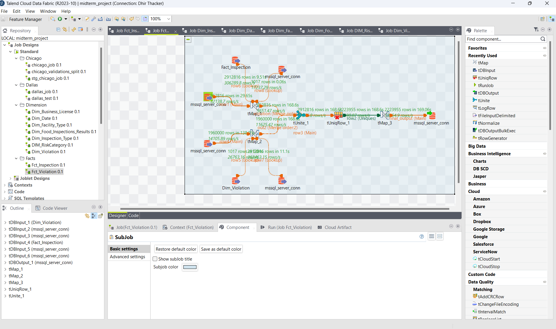

T-Map 1 of Fact_Violation

T-Map 2 of Fact_Violation

T-Map 3 of Fact_Violation

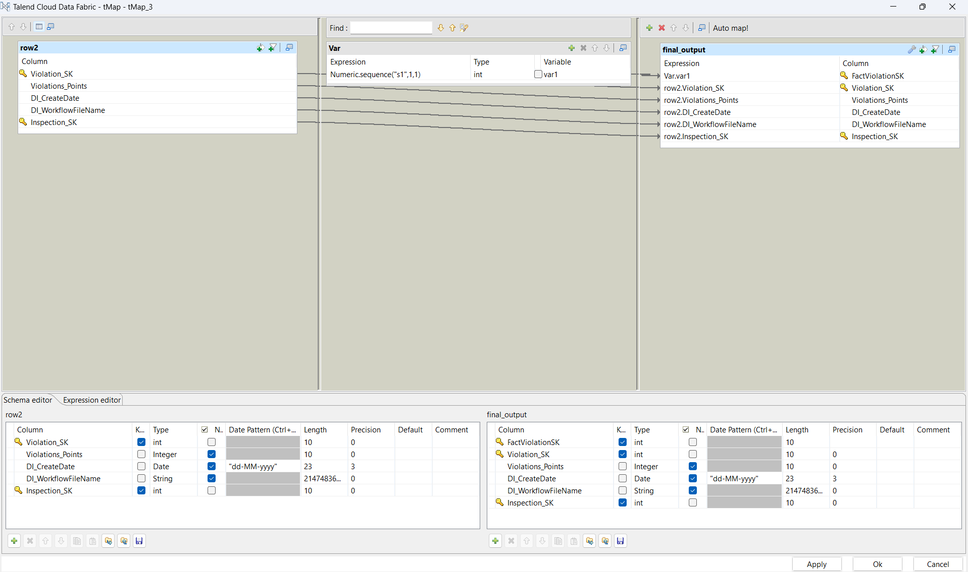

T-UniqRow of Fact_Violation

